**FOP LAB TASK 6**

**ABDUL MANAN**

**462449**

**TASK1**

#include <iostream>

using namespace std;

int main() {

int sum = 0, t, num1 = 0, num2 = 1;

cout<<"Please enter the number of terms: ";

cin>>t;

sum = num1 + num2;

cout<<num1<<" \t"<<num2<<" \t"<<sum<<" \t";

for (int i = 0; i<t-3; i++) {

num1 = num2;

num2 = sum;

sum = num1 + num2;

for (int j = 0; j<1; j++) {

cout<<sum<<" \t";

}

}

return 0;

}

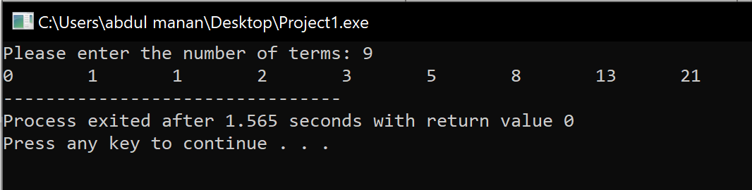

**TASK 2**

#include <iostream>

using namespace std;

int main() {

int rows, num = 0;

cout<<"Enter the number of rows"<<endl;

cin>>rows;

for (int i=1;i<=rows;i++) {

for (int j = 1; j<=i; j++){

cout<<"\t"<<++num;

}

cout<<"\n";

}

return 0;

}

